Internet Cafe Business Plan

Javanet Internet Café (START-UP BUSINESS)

*****************************SAMPLE***************************************

Plan Outline
- Executive Summary
- Company Summary
- Services
- Market Analysis Summary
- Marketing Strategy and Implementation Plan
- Management Plan
- Financial Plan
- Appendix

Executive Summary
JavaNet, unlike a typical cafe, will provide a unique forum for communication and entertainment through the medium of the Internet. JavaNet is the answer to an increasing demand. The public wants: (1) access to the methods of communication and volumes of information now available on the Internet, and (2) access at a cost they can afford and in such a way that they aren't socially, economically, or politically isolated. JavaNet 's goal is to provide the community with a social, educational, entertaining, atmosphere for worldwide communication.
This business plan is prepared to obtain financing in the amount of $24,000. The supplemental financing is required to begin work on site preparation and modifications, equipment purchases, and to cover expenses in the first year of operations. Additional financing has already been secured in the form of: (1) $24,000 from the Sun Economic Development Fund (2) $19,000 of personal savings from owner Cale Bruckner (3) $36,000 from three investors (4) and $9,290 in the form of short-term loans.
JavaNet will be incorporated as an LLC corporation. This will shield the owner Cale Bruckner, and the three outside investors,Luke Walsh, Doug Wilson, and John Underwood, from issues of personal liability and double taxation. The investors will be treated as shareholders and therefore will not be liable for more than their individual personal investment of $12,000 each.
The financing, in addition to the capital contributions from the owner, shareholders and the Sun Economic Development Fund, will allow JavaNet to successfully open and maintain operations through year one. The large initial capital investment will allow JavaNet to provide its customers with a full featured Internet cafe. A unique, upscale, and innovative environment is required to provide the customers with an atmosphere that will spawn socialization. Successful operation in year one will provide JavaNet with a customer base that will allow it to be self sufficient in year two.

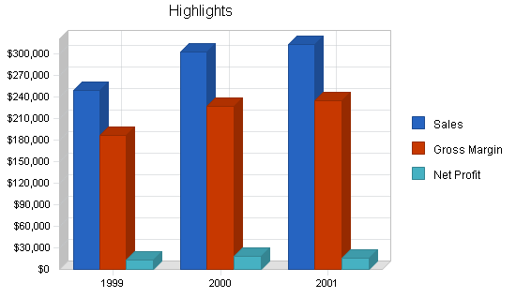

1.1 Objectives
JavaNet's objectives for the first three years of operation include:
- The creation of a unique, upscale, innovative environment that will differentiate JavaNet from local coffee houses.
- Educating the community on what the Internet has to offer.
- The formation of an environment that will bring people with diverse interests and backgrounds together in a common forum.
- Good coffee and bakery items at a reasonable price.
- Affordable access to the resources of the Internet and other online services.

1.2 Keys to Success
The keys to the success for JavaNet are:
- The creation of a unique, innovative, upscale atmosphere that will differentiate JavaNet from other local coffee shops and future Internet cafes.
- The establishment of JavaNet as a community hub for socialization and entertainment.
- The creation of an environment that won't intimidate the novice user. JavaNet will position itself as an educational resource for individuals wishing to learn about the benefits the Internet has to offer.
- Great coffee and bakery items.

1.3 Mission
As the popularity of the Internet continues to grow at an exponential rate, easy and affordable access is quickly becoming a necessity of life. JavaNet provides communities with the ability to access the Internet, enjoy a cup of coffee, and share Internet experiences in a comfortable environment. People of all ages and backgrounds will come to enjoy the unique, upscale, educational, and innovative environment that JavaNet provides.

1.4 Risks
The risks involved with starting JavaNet are:
- Will there be a demand for the services offered by JavaNet in Eugene?
- Will the popularity of the Internet continue to grow, or is the Internet a fad?
- Will individuals be willing to pay for the service JavaNet offers?
- Will the cost of accessing the Internet from home drop so significantly that there will not be a market for Internet Cafes such as JavaNet?

Company Summary
JavaNet, soon to be located in downtown Eugene on 10th and Oak, will offer the community easy and affordable access to the Internet. JavaNet will provide full access to email, WWW, FTP, Usenet and other Internet applications such as Telnet and Gopher. JavaNet will also provide customers with a unique and innovative environment for enjoying great coffee, specialty beverages, and bakery items.
JavaNet will appeal to individuals of all ages and backgrounds. The instructional Internet classes, and the helpful staff that JavaNet provides, will appeal to the audience that does not associate themselves with the computer age. This educational aspect will attract younger and elderly members of the community who are rapidly gaining interest in the unique resources that online communications have to offer. The downtown location will provide business people with convenient access to their morning coffee and online needs.

2.1 Company Ownership
JavaNet is a privately held Oregon Limited Liability Corporation. Cale Bruckner, the founder of JavaNet, is the majority owner. Luke Walsh, Doug Wilson, and John Underwood, all hold minority stock positions as private investors.

2.2 Start-up Summary
JavaNet's start-up costs will cover coffee making equipment, site renovation and modification, capital to cover losses in the first year, and the communications equipment necessary to get its customers online.
The communications equipment necessary to provide JavaNet's customers with a high-speed connection to the Internet and the services it has to offer make up a large portion of the start-up costs. These costs will include the computer terminals and all costs associated with their set-up. Costs will also be designated for the purchase of two laser printers and a scanner.
In addition, costs will be allocated for the purchase of coffee making equipment. One espresso machine, an automatic coffee grinder, and minor additional equipment will be purchased from Allann Brothers.
The site at 10th and Oak will require funds for renovation and modification. A single estimated figure will be allocated for this purpose. The renovation/modification cost estimate will include the costs associated with preparing the site for opening business.
Start-up Expense Details:
- 11 computers = $22,000
- two printers = $1,000
- one scanner = $500
- software = $810
- one espresso machine = $10,700
- one automatic espresso grinder = $795
- other fixtures and remodeling:
  - two coffee/food preparation counters = $1,000
  - one information display counter = $1,000
  - one drinking/eating counter = $500
  - sixteen stools = $1,600
  - six computer desks w/chairs = $2,400
  - stationery goods = $500
  - two telephones = $200
  - decoration expense = $13,000

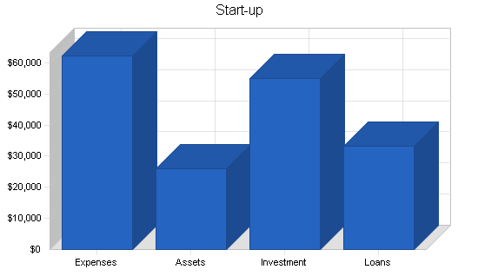

Start-up
Requirements
Start-up Expenses
Legal | $500
Stationery etc. | $500
Brochures | $500
Consultants | $2,000
Insurance | $700
Rent | $1,445
4-group Automatic Coffee Machine | $10,700
Bean Grinder | $795
Computer Systems (x11), Software, Printer, Scanner | $24,310
Communication Lines | $840
Fixtures/Remodel | $20,000
Total Start-up Expenses | $62,290
Start-up Assets
Cash Required | $24,000
Start-up Inventory | $2,000
Other Current Assets | $0
Long-term Assets | $0
Total Assets | $26,000
Total Requirements | $88,290

2.3 Company Locations and Facilities
A site has been chosen at 10th and Oak in downtown Eugene. This site was chosen for various reasons, including:
- Proximity to the downtown business community.
- Proximity to trendy, upscale restaurants such as West Brothers.
- Proximity to LTD's Eugene Station. Parking availability.
- Low cost rent - $.85 per square foot for 1700 square feet.
- High visibility.
All of these qualities are consistent with JavaNet's goal of providing a central hub of communication and socialization for the Eugene community

Services
JavaNet will provide full access to email, WWW, FTP, Usenet and other Internet applications such as Telnet and Gopher. Printing, scanning, and introductory courses to the Internet will also be available to the customer. JavaNet will also provide customers with a unique and innovative environment for enjoying great coffee, specialty beverages, and bakery items.

3.1 Service Description
JavaNet will provide its customers with full access to the Internet and common computer software and hardware. Some of the Internet and computing services available to JavaNet customers are listed below:
- Access to external POP3 email accounts.
- Customers can sign up for a JavaNet email account. This account will be managed by JavaNet servers and accessible from computer systems outside the JavaNet network.
- FTP, Telnet, Gopher, and other popular Internet utilities will be available.
- Access to Netscape or Internet Explorer browser.
- Access to laser and color printing.
- Access to popular software applications like Adobe PhotoShop and Microsoft Word.
JavaNet will also provide its customers with access to introductory Internet and email classes. These classes will be held in the afternoon and late in the evening. By providing these classes, JavaNet will build a client base familiar with its services. The computers, Internet access, and classes wouldn't mean half as much if taken out of the environment JavaNet will provide. Good coffee, specialty drinks, bakery goods, and a comfortable environment will provide JavaNet customers with a home away from home. A place to enjoy the benefits of computing in a comfortable and well-kept environment.

3.2 Competitive Comparison
JavaNet will be the first Internet cafe in Eugene. JavaNet will differentiate itself from the strictly-coffee cafes in Eugene by providing its customers with Internet and computing services.

3.3 Fulfillment
JavaNet will obtain computer support and Internet access from Bellevue Computers located in Eugene. Bellevue will provide the Internet connections, network consulting, and the hardware required to run the JavaNetwork. Allann Brothers will provide JavaNet with coffee equipment, bulk coffee, and paper supplies. At this time, a contract for the bakery items has not been completed. JavaNet is currently negotiating with Humble Bagel and the French Horn to fulfill the requirement.

3.4 Technology
JavaNet will invest in high-speed computers to provide its customers with a fast and efficient connection to the Internet. The computers will be reliable and fun to work with. JavaNet will continue to upgrade and modify the systems to stay current with communications technology. One of the main attractions associated with Internet cafes, is the state of the art equipment available for use. Not everyone has a Pentium PC in their home or office.

3.5 Future Services
As JavaNet grows, more communications systems will be added. The possibility of additional units has been accounted for in the current floor plan. As the demand for Internet connectivity increases, along with the increase in competition, JavaNet will continue to add new services to keep its customer base coming back for more.

Market Analysis Summary
JavaNet is faced with the exciting opportunity of being the first-mover in the Eugene cyber-cafe market. The consistent popularity of coffee, combined with the growing interest in the Internet, has been proven to be a winning concept in other markets and will produce the same results in Eugene.

4.1 Market Segmentation
JavaNet's customers can be divided into two groups. The first group is familiar with the Internet and desires a progressive and inviting atmosphere where they can get out of their offices or bedrooms and enjoy a great cup of coffee. The second group is not familiar with the Internet, yet, and is just waiting for the right opportunity to enter the online community. JavaNet's target market falls anywhere between the ages of 18 and 50. This extremely wide range of ages is due to the fact that both coffee and the Internet appeal to a variety of people. In addition to these two broad categories, JavaNet's target market can be divided into more specific market segments. The majority of these individuals are students and business people. See the Market Analysis chart and table below for more specifics.

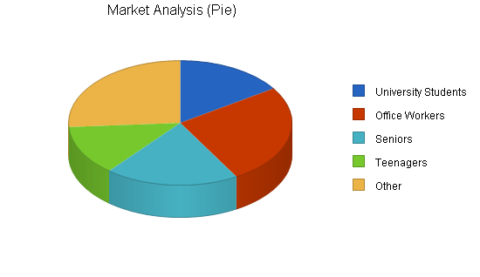

Market Analysis
 |  | 1999 | 2000 | 2001 | 2002 | 2003
Potential Customers | Growth |  |  |  |  |  | CAGR
University Students | 4% | 15,000 | 15,600 | 16,224 | 16,873 | 17,548 | 4.00%
Office Workers | 3% | 25,000 | 25,750 | 26,523 | 27,319 | 28,139 | 3.00%
Seniors | 5% | 18,500 | 19,425 | 20,396 | 21,416 | 22,487 | 5.00%
Teenagers | 2% | 12,500 | 12,750 | 13,005 | 13,265 | 13,530 | 2.00%
Other | 0% | 25,000 | 25,000 | 25,000 | 25,000 | 25,000 | 0.00%
Total | 2.68% | 96,000 | 98,525 | 101,148 | 103,873 | 106,704 | 2.68%

4.2 Target Market Segment Strategy
JavaNet intends to cater to people who want a guided tour on their first spin around the Internet and to experienced users eager to indulge their passion for computers in a social setting. Furthermore, JavaNet will be a magnet for local and traveling professionals who desire to work or check their email messages in a friendly atmosphere. These professionals will either use JavaNet's PCs, or plug their notebooks into Internet connections. JavaNet's target market covers a wide range of ages: from members of Generation X who grew up surrounded by computers, to Baby Boomers who have come to the realization that people today cannot afford to ignore computers.

4.2.1 Market Trends
A market survey was conducted in the Fall of 1996. Key questions were asked of fifty potential customers. Some key findings include:
- 35 subjects said they would be willing to pay for access to the Internet.
- Five dollars an hour was the most popular hourly Internet fee.
- 24 subjects use the Internet to communicate with others on a regular basis.

4.2.2 Market Needs
Factors such as current trends, addiction, and historical sales data ensure that the high demand for coffee will remain constant over the next five years. The rapid growth of the Internet and online services, that has been witnessed worldwide, is only the tip of the iceberg. The potential growth of the Internet is enormous, to the point where one day, a computer terminal with an online connection will be as common and necessary as a telephone. This may be 10 or 20 years down the road, but for the next five years, the online service provider market is sure to experience tremendous growth. Being the first cyber-cafe in Eugene, JavaNet will enjoy the first-mover advantages of name recognition and customer loyalty. Initially, JavaNet will hold a 100 percent share of the cyber-cafe market in Eugene. In the next five years, competitors will enter the market. JavaNet has set a goal to maintain greater than a 50 percent market share.

4.3 Service Business Analysis
The retail coffee industry in Eugene experienced rapid growth at the beginning of the decade and is now moving into the mature stage of its life cycle. Many factors contribute to the large demand for good coffee in Eugene. The University is a main source of demand for coffee retailers. The climate in Eugene is extremely conducive to coffee consumption. Current trends in the Northwest reflect the popularity of fresh, strong, quality coffee and specialty drinks. Eugene is a haven for coffee lovers.
The popularity of the Internet is growing exponentially. Those who are familiar with the Internet are well aware of how fun and addictive surfing the Net can be. Those who have not yet experienced the Internet, need a convenient, relaxed atmosphere where they can feel comfortable learning about and utilizing the current technologies. JavaNet seeks to provide its customers with affordable Internet access in an innovative and supportive environment.
Due to intense competition, cafe owners must look for ways to differentiate their place of business from others in order to achieve and maintain a competitive advantage. The founder of JavaNet realizes the need for differentiation and strongly believes that combining a cafe with complete Internet service is the key to success. The fact that no cyber-cafes are established in Eugene, presents JavaNet with a chance to enter the window of opportunity and enter into a profitable niche in the market.

4.3.1 Competition and Buying Patterns
The main competitors in the retail coffee segment are Cafe Paradisio, Full City, Coffee Corner and Allann Bros. These businesses are located in or near the downtown area, and target a similar segment to JavaNet's (i.e. educated, upwardly-mobile students and business people).
Competition from online service providers comes from locally-owned businesses as well as national firms. There are approximately eight, local, online service providers in Eugene. This number is expected to grow with the increasing demand for Internet access. Larger, online service providers, such as AOL and CompuServe are also a competitive threat to JavaNet. Due to the nature of the Internet, there are no geographical boundaries restricting competition.

4.3.2 Business Participants
There are approximately 16 coffee wholesalers in Lane County. These wholesalers distribute coffee and espresso beans to over 20 retailers in the Eugene area. Competition in both channels creates an even amount of bargaining power between buyers and suppliers resulting in extremely competitive pricing. Some of these major players in the industry (i.e. Allann Brothers Coffee Co., Inc. and Coffee Corner Ltd.) distribute and retail coffee products.
The number of online service providers in Eugene is approximately eight and counting. These small, regional service providers use a number of different pricing strategies. Some charge a monthly fee, while others charge hourly and/or phone fees. Regardless of the pricing method used, obtaining Internet access through one of these firms can be expensive. Larger Internet servers such as America Online (AOL), Prodigy, and CompuServe, are also fighting for market share in this rapidly growing industry. These service providers are also rather costly for the average consumer. Consumers who are not convinced they would frequently and consistently travel the Internet, will not be willing to pay these prices.

4.3.3 Distributing a Service
The dual product/service nature of JavaNet's business faces competition on two levels. JavaNet competes not only with coffee retailers, but also with Internet service providers. The good news is that JavaNet does not currently face any direct competition from other cyber-cafes in the Eugene market. There are a total of three cyber-cafes in the state of Oregon: one located in Portland and two in Ashland.
Heavy competition between coffee retailers in Eugene creates an industry where all firms face the same costs. There is a positive relationship between price and quality of coffee. Some coffees retail at $8/pound while other, more exotic beans may sell for as high as $16/pound. Wholesalers sell beans to retailers at an average of a 50 percent discount. For example, a pound of Sumatran beans wholesales for $6.95 and retails for $13.95. And as in most industries, price decreases as volume increases.

Marketing Strategy and Implementation Summary
JavaNet has three main strategies. The first strategy focuses on attracting novice Internet users. By providing a novice friendly environment, JavaNet hopes to educate and train a loyal customer base.
The second, and most important, strategy focuses on pulling in power Internet users. Power Internet users are extremely familiar with the Internet and its offerings. This group of customers serves an important function at JavaNet. Power users have knowledge and web-browsing experience that novice Internet users find attractive and exciting.
The third strategy focuses on building a social environment for JavaNet customers. A social environment, that provides entertainment, will serve to attract customers that wouldn't normally think about using the Internet. Once on location at JavaNet, these customers that came for the more standard entertainment offerings, will realize the potential entertainment value the Internet can provide.

5.1 SWOT Analysis
The SWOT analysis provides us with an opportunity to examine the internal strengths and weaknesses JavaNet must address. It also allows us to examine the opportunities presented to JavaNet as well as potential threats.
JavaNet has a valuable inventory of strengths that will help it succeed. These strengths include: a knowledgeable and friendly staff, state-of-the-art computer hardware, and a clear vision of the market need. Strengths are valuable, but it is also important to realize the weaknesses JavaNet must address. These weaknesses include: a dependence on quickly changing technology, and the cost factor associated with keeping state-of-the art computer hardware.
JavaNet's strengths will help it capitalize on emerging opportunities. These opportunities include, but are not limited to, a growing population of daily Internet users, and the growing social bonds fostered by the new Internet communities. Threats that JavaNet should be aware of include, the rapidly falling cost of Internet access, and emerging local competitors.

5.1.1 Strengths
- Knowledgeable and friendly staff. We've gone to great lengths at JavaNet to find people with a passion for teaching and sharing their Internet experiences. Our staff is both knowledgeable and eager to please.
- State-of-the art equipment. Part of the JavaNet experience includes access to state-of-the-art computer equipment. Our customers enjoy beautiful flat-screen displays, fast machines, and high-quality printers.
- Upscale ambiance. When you walk into JavaNet, you'll feel the technology. High backed mahogany booths with flat-screen monitors inset into the walls provide a cozy hideaway for meetings and small friendly gatherings. Large round tables with displays viewable from above provide a forum for larger gatherings and friendly "how-to" classes on the Internet. Aluminum track lighting and art from local artists sets the mood. Last, but not least, quality cappuccino machines and a glass pastry display case provide enticing refreshments.
- Clear vision of the market need. JavaNet knows what it takes to build an upscale cyber cafe. We know the customers, we know the technology, and we know how to build the service that will bring the two together.

5.1.2 Weaknesses
- A dependence on quickly changing technology. JavaNet is a place for people to experience the technology of the Internet. The technology that is the Internet changes rapidly. Product lifecycles are measured in weeks, not months. JavaNet needs to keep up with the technology because a lot of the JavaNet experience is technology.
- Cost factor associated with keeping state-of-the-art hardware. Keeping up with the technology of the Internet is an expensive undertaking. JavaNet needs to balance technology needs with the other needs of the business. One aspect of the business can't be sacrificed for the other.

5.1.3 Opportunities
- Growing population of daily Internet users. The importance of the Internet almost equals that of the telephone. As the population of daily Internet users increases, so will the need for the services JavaNet offers.
- Social bonds fostered by the new Internet communities. The Internet is bringing people from across the world together unlike any other communication medium. JavaNet will capitalize on this social trend by providing a place for smaller and local Internet communities to meet in person. JavaNet will grow some of these communities on its own by establishing chat areas and community programs. These programs will be designed to build customer loyalty.

5.1.4 Threats
- Rapidly falling cost of Internet access. The cost of access to the Internet for home users is dropping rapidly. Internet access may become so cheap and affordable that nobody will be willing to pay for access to it. JavaNet is aware of this threat and will closely monitor pricing.
- Emerging local competitors. Currently, JavaNet is enjoying a first-mover advantage in the local cyber-cafe market. However, additional competitors are on the horizon, and we need to be prepared for their entry into the market. Many of our programs will be designed to build customer loyalty, and it is our hope that our quality service and up-scale ambiance won't be easily duplicated.

5.2 Strategy Pyramid
The following subtopics provide an overview of JavaNet's three key strategies. Strategy pyramid graphics are presented in the appendix of this plan.

5.2.1 Attract Novice Internet Users
JavaNet's first strategy focuses on attracting novice Internet users. JavaNet plans on attracting these customers by:
- Providing a novice friendly environment. JavaNet will be staffed by knowledgeable employees focused on serving the customer's needs.
- A customer service desk will always be staffed. If a customer has any type of question or concern, a JavaNet employee will always be available to assist.
- JavaNet will offer introductory classes on the Internet and email. These classes will be designed to help novice users familiarize themselves with these key tools and the JavaNet computer systems.

5.2.2 Attract Power Internet Users
JavaNet's second strategy will be focused on attracting power Internet users. Power Internet users provide an important function at JavaNet. JavaNet plans on attracting this type of customer by:
- Providing the latest in computing technology.
- Providing scanning and printing services.
- Providing access to powerful software applications.

5.2.3 Social Hub
The third strategy focuses on building a social environment for JavaNet customers. A social environment, that provides entertainment, will serve to attract customers that wouldn't normally think about using the Internet. Once on location at JavaNet, these customers that came for the more standard entertainment offerings, will realize the potential entertainment value the Internet can provide.

5.3 Competitive Edge
JavaNet will follow a differentiation strategy to achieve a competitive advantage in the cafe market. By providing Internet service, JavaNet separates itself from all other cafes in Eugene. In addition, JavaNet provides a comfortable environment with coffee and bakery items, distinguishing itself from other Internet providers in Eugene.

5.4 Milestones
The JavaNet management team has established some basic milestones to keep the business plan priorities in place. Responsibility for implementation falls on the shoulders of Cale Bruckner. This Milestones Table below will be updated as the year progresses using the actual tables. New milestones will be added as the first year of operations commences.

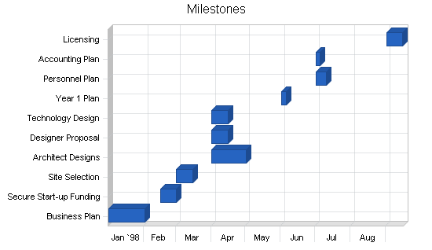

Milestones
Milestone | Start Date | End Date | Budget | Manager | Department
Business Plan | 1/1/1998 | 2/1/1998 | $1,000 | Cale Bruckner | Admin
Secure Start-up Funding | 2/15/1998 | 3/1/1998 | $1,000 | Cale Bruckner | Admin
Site Selection | 3/1/1998 | 3/15/1998 | $1,000 | Cale Bruckner | Admin
Architect Designs | 4/1/1998 | 5/1/1998 | $1,000 | Cale Bruckner | Admin
Designer Proposal | 4/1/1998 | 4/15/1998 | $1,000 | Cale Bruckner | Admin
Technology Design | 4/1/1998 | 4/15/1998 | $1,000 | Cale Bruckner | Admin
Year 1 Plan | 6/1/1998 | 6/5/1998 | $1,000 | Cale Bruckner | Admin
Personnel Plan | 7/1/1998 | 7/10/1998 | $1,000 | Cale Bruckner | Admin
Accounting Plan | 7/1/1998 | 7/5/1998 | $1,000 | Cale Bruckner | Admin
Licensing | 9/1/1998 | 9/15/1998 | $1,000 | Cale Bruckner | Admin
Totals |  |  | $10,000

5.5 Marketing Strategy
JavaNet will position itself as an upscale coffee house and Internet service provider. It will serve high-quality coffee and espresso specialty drinks at a competitive price. Due to the number of cafes in Eugene, it is important that JavaNet sets fair prices for its coffee. JavaNet will use advertising as its main source of promotion. Ads placed in The Register Guard, Eugene Weekly, and the Emerald will help build customer awareness. Accompanying the ad will be a coupon for a free hour of Internet travel. Furthermore, JavaNet will give away three free hours of Internet use to beginners who sign up for an introduction to the Internet workshop provided by JavaNet.

5.5.1 Promotion Strategy
JavaNet will implement a pull strategy in order to build consumer awareness and demand. Initially, JavaNet has budgeted $5,000 for promotional efforts which will include advertising with coupons for a free hour of Internet time in local publications and in-house promotions such as offering customers free Internet time if they pay for an introduction to the Internet workshop taught by JavaNet's computer technician.
JavaNet realizes that in the future, when competition enters the market, additional revenues must be allocated for promotion in order to maintain market share.

5.5.2 Pricing Strategy
JavaNet bases its prices for coffee and specialty drinks on the "retail profit analysis" provided by our supplier, Allann Brothers Coffee Co., Inc. Allann Brothers has been in the coffee business for 22 years and has developed a solid pricing strategy.
Determining a fair market, hourly price, for online use is more difficult because there is no direct competition from another cyber-cafe in Eugene. Therefore, JavaNet considered three sources to determine the hourly charge rate. First, we considered the cost to use other Internet servers, whether it is a local networking firm or a provider such as America Online. Internet access providers use different pricing schemes. Some charge a monthly fee, while others charge an hourly fee. In addition, some providers use a strategy with a combination of both pricing schemes. Thus, it can quickly become a high monthly cost for the individual. Second, JavaNet looked at how cyber-cafes in other markets such as Portland and Ashland went about pricing Internet access. Third, JavaNet used the market survey conducted in the Fall of 1996. Evaluating these three factors resulted in JavaNet's hourly price of five dollars.

5.6 Sales Strategy
As a retail establishment, JavaNet employs people to handle sales transactions. Computer literacy is a requirement for JavaNet employees. If an employee does not possess basic computer skills when they are hired, they are trained by our full-time technician. Our full-time technician is also available for customers in need of assistance. JavaNet's commitment to friendly, helpful service is one of the key factors that distinguishes JavaNet from other Internet cafes.

5.6.1 Sales Forecast
Sales forecast data is presented in the chart and table below.
Sales: JavaNet is basing their projected coffee and espresso sales on the financial snapshot information provided to them by Allann Bros. Coffee Co. Internet sales were estimated by calculating the total number of hours each terminal will be active each day and then generating a conservative estimate as to how many hours will be purchased by consumers.
Cost of Sales: The cost of goods sold for coffee-related products was determined by the "retail profit analysis" we obtained from Allann Bros. Coffee Co. The cost of bakery items is 20% of the selling price. The cost of Internet access is $660 per month, paid to Bellevue Computers for networking fees. The cost of e-mail accounts is 25% of the selling price.

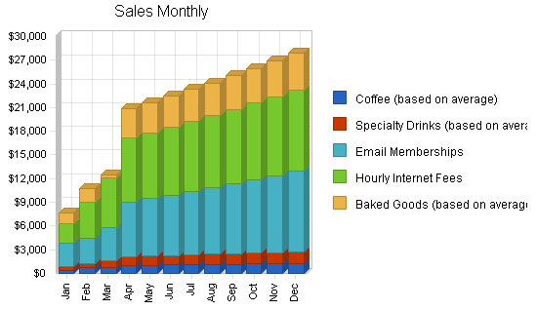

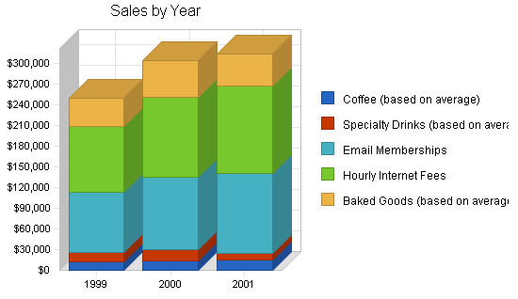

Sales Forecast
 | 1999 | 2000 | 2001
Unit Sales
Coffee (based on average) | 12,016 | 14,068 | 15,475
Specialty Drinks (based on average) | 6,654 | 7,913 | 8,705
Email Memberships | 8,703 | 10,505 | 11,556
Hourly Internet Fees | 38,269 | 46,365 | 51,002
Baked Goods (based on average) | 32,673 | 42,150 | 46,365
Total Unit Sales | 98,315 | 121,001 | 133,103
Unit Prices | 1999 | 2000 | 2001
Coffee (based on average) | $1.00 | $1.00 | $1.00
Specialty Drinks (based on average) | $2.00 | $2.00 | $1.00
Email Memberships | $10.00 | $10.00 | $10.00
Hourly Internet Fees | $2.50 | $2.50 | $2.50
Baked Goods (based on average) | $1.25 | $1.25 | $1.00
Sales
Coffee (based on average) | $12,016 | $14,068 | $15,475
Specialty Drinks (based on average) | $13,308 | $15,826 | $8,705
Email Memberships | $87,030 | $105,050 | $115,560
Hourly Internet Fees | $95,673 | $115,913 | $127,505
Baked Goods (based on average) | $40,841 | $52,688 | $46,365
Total Sales | $248,868 | $303,544 | $313,610
Direct Unit Costs | 1999 | 2000 | 2001
Coffee (based on average) | $0.25 | $0.25 | $0.25
Specialty Drinks (based on average) | $0.50 | $0.50 | $0.25
Email Memberships | $2.50 | $2.50 | $2.50
Hourly Internet Fees | $0.63 | $0.63 | $0.63
Baked Goods (based on average) | $0.31 | $0.31 | $0.25
Direct Cost of Sales
Coffee (based on average) | $3,004 | $3,517 | $3,869
Specialty Drinks (based on average) | $3,327 | $3,957 | $2,176
Email Memberships | $21,758 | $26,263 | $28,890
Hourly Internet Fees | $23,918 | $28,978 | $31,876
Baked Goods (based on average) | $10,210 | $13,172 | $11,591
Subtotal Direct Cost of Sales | $62,217 | $75,886 | $78,403

Management Plan
JavaNet is owned and operated by Mr. Cale Bruckner. The company, being small in nature, requires a simple organizational structure. Implementation of this organizational form calls for the owner, Mr. Bruckner, to make all of the major management decisions in addition to monitoring all other business activities.

6.1 Personnel Plan
The staff will consist of six part-time employees working thirty hours a week at $5.50 per hour. In addition, one full-time technician (who is more technologically oriented to handle minor terminal repairs/inquiries) will be employed to work forty hours a week at $10.00 per hour. The three private investors, Luke Walsh, Doug Wilson and John Underwood will not be included in management decisions. This simple structure provides a great deal of flexibility and allows communication to disperse quickly and directly. Because of these characteristics, there are few coordination problems seen at JavaNet that are common within larger organizational chains. This strategy will enable JavaNet to react quickly to changes in the market.

Personnel Plan
 | 1999 | 2000 | 2001
Owner | $24,000 | $26,400 | $29,040
Part Time 1 | $7,920 | $7,920 | $7,920
Part Time 2 | $7,920 | $7,920 | $7,920
Part Time 3 | $7,920 | $7,920 | $7,920
Part Time 4 | $7,920 | $7,920 | $7,920
Part Time 5 | $7,920 | $7,920 | $7,920
Part Time 6 | $3,960 | $7,920 | $7,920
Technician | $21,731 | $23,904 | $26,294
Manager | $4,000 | $24,000 | $26,400
Total People | 9 | 9 | 9
Total Payroll | $93,291 | $121,824 | $129,254

Financial Plan
The following sections lay out the details of our financial plan for the next three years.

7.2 Start-up Funding
This business plan is prepared to obtain financing in the amount of $24,000. The supplemental financing is required to begin work on site preparation and modifications, equipment purchases, and to cover expenses in the first year of operations.
Additional financing has already been secured as follows:
- $24,000 from the Oregon Economic Development Fund
- $19,000 of personal savings from owner Cale Bruckner
- $36,000 from three investors
- and $9,290 in the form of short-term loans

Start-up Funding
Start-up Expenses to Fund | $62,290
Start-up Assets to Fund | $26,000
Total Funding Required | $88,290
Assets
Non-cash Assets from Start-up | $2,000
Cash Requirements from Start-up | $24,000
Additional Cash Raised | $0
Cash Balance on Starting Date | $24,000
Total Assets | $26,000
Liabilities and Capital
Liabilities
Current Borrowing | $9,290
Long-term Liabilities | $24,000
Accounts Payable (Outstanding Bills) | $0
Other Current Liabilities (interest-free) | $0
Total Liabilities | $33,290
Capital
Planned Investment
Cale Bruckner | $19,000
Luke Walsh | $12,000
Doug Wilson | $12,000
John Underwood | $12,000
Additional Investment Requirement | $0
Total Planned Investment | $55,000
Loss at Start-up (Start-up Expenses) | ($62,290)
Total Capital | ($7,290)
Total Capital and Liabilities | $26,000
Total Funding | $88,290

7.3 Important Assumptions
Basic assumptions are presented in the table below.

General Assumptions
 | 1999 | 2000 | 2001
Plan Month | 1 | 2 | 3
Current Interest Rate | 8.00% | 8.00% | 8.00%
Long-term Interest Rate | 10.00% | 10.00% | 10.00%
Tax Rate | 30.00% | 30.00% | 30.00%
Other | 0 | 0 | 0

7.4 Key Financial Indicators
Important benchmark data is presented in the chart below.

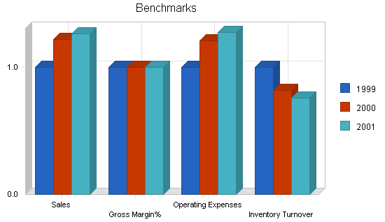

7.5 Break-even Analysis
Break-even data is presented in the chart and table below.

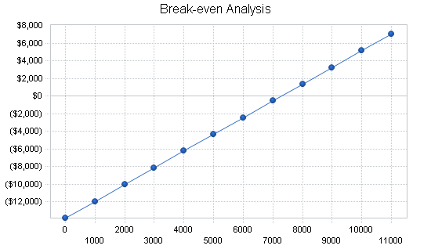

Break-even Analysis
Monthly Units Break-even | 7,294
Monthly Revenue Break-even | $18,462
Assumptions:
Average Per-Unit Revenue | $2.53
Average Per-Unit Variable Cost | $0.63
Estimated Monthly Fixed Cost | $13,847

7.6 Projected Profit and Loss
Payroll Expense: The founder of JavaNet, Cale Bruckner, will receive a salary of $24,000 in year one, $26,400 in year two, and $29,040 in year three. JavaNet intends to hire six part-time employees by the end of year one at $5.75/hour and a full-time technician at $10.00/hour.
Rent Expense: JavaNet is leasing a 1700 square foot facility at $.85/sq. foot. The lease agreement JavaNet signed specifies that we pay $2,000/month for a total of 36 months. At the end of the third year, the lease is open for negotiations and JavaNet may or may not re-sign the lease depending on the demands of the lessor.
Utilities Expense: As stated in the contract, the lessor is responsible for the payment of utilities including gas, garbage disposal, and real estate taxes. The only utilities expense that JavaNet must pay is the phone bill generated by fifteen phone lines; thirteen will be dedicated to modems and two for business purposes. The basic monthly service charge for each line provided by US West is $17.29. The 13 lines used to connect the modems will make local calls to the network provided by Bellevue resulting in a monthly charge of $224.77. The two additional lines used for business communication will cost $34.58/month plus long distance fees. JavaNet assumes that it will not make more than $40.00/month in long distance calls. Therefore, the total cost associated with the two business lines is estimated at $74.58/month and the total phone expense at $299.35/month. In addition, there will be an additional utility expense of $800 for estimated EWEB bills.
Marketing Expense: JavaNet will allocate $33,750 for promotional expenses over the first year. These dollars will be used for advertising in local newspapers in order to build consumer awareness. For additional information, please refer to section 5.0 of the business plan.
Insurance Expense: JavaNet has allocated $1,440 for insurance for the first year. As revenue increases in the second and third year of business, JavaNet intends to invest more money for additional insurance coverage.
Depreciation: In depreciating our capital equipment, JavaNet used the Modified Accelerated Cost Recovery Method. We depreciated our computers over a five-year time period and our fixtures over seven years.
Taxes: JavaNet is an LLC and, as an entity, it is not taxed. However, there is a 15% payroll burden.
Detailed Profit and Loss data is presented in the table below.

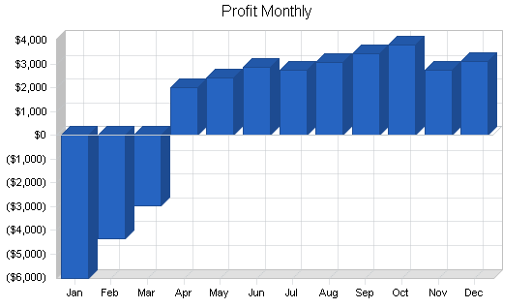

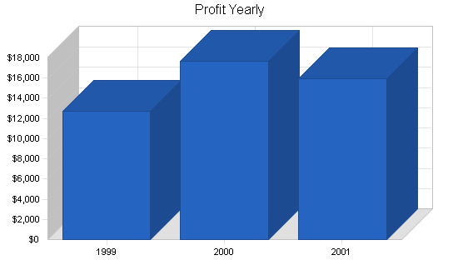

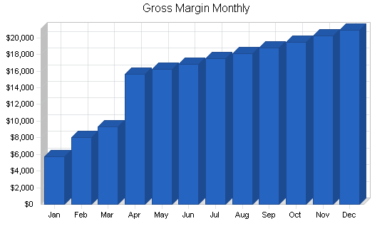

Pro Forma Profit and Loss
 | 1999 | 2000 | 2001
Sales | $248,868 | $303,544 | $313,610
Direct Cost of Sales | $62,217 | $75,886 | $78,403
Other Costs of Sales | $0 | $0 | $0
Total Cost of Sales | $62,217 | $75,886 | $78,403
Gross Margin | $186,651 | $227,658 | $235,208
Gross Margin % | 75.00% | 75.00% | 75.00%
Expenses
Payroll | $93,291 | $121,824 | $129,254
Marketing/Promotion | $33,750 | $40,000 | $43,000
Depreciation | $0 | $0 | $0
Rent | $24,000 | $24,000 | $24,000
Utilities | $9,120 | $9,120 | $9,120
Insurance | $6,000 | $6,000 | $6,000
Payroll Taxes | $0 | $0 | $0
Other | $0 | $0 | $0
Total Operating Expenses | $166,161 | $200,944 | $211,374
Profit Before Interest and Taxes | $20,490 | $26,714 | $23,834
EBITDA | $20,490 | $26,714 | $23,834
Interest Expense | $2,325 | $1,470 | $1,100
Taxes Incurred | $5,450 | $7,573 | $6,820
Net Profit | $12,716 | $17,671 | $15,913
Net Profit/Sales | 5.11% | 5.82% | 5.07%

7.7 Projected Cash Flow
Cash flow data is presented in the chart and table below.
Accounts Payable: JavaNet acquired a $24,000 loan from a bank at a 10% interest rate. The loan will be paid back at $800/month over the next three years. The $9,290 short term loan will be paid back at a rate of 8%.

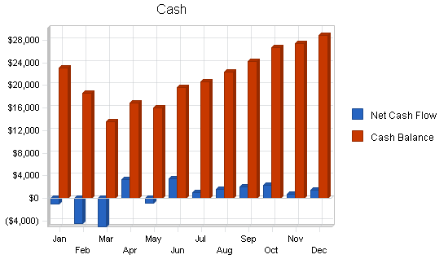

Pro Forma Cash Flow
 | 1999 | 2000 | 2001
Cash Received
Cash from Operations
Cash Sales | $248,868 | $303,544 | $313,610
Subtotal Cash from Operations | $248,868 | $303,544 | $313,610
Additional Cash Received
Sales Tax, VAT, HST/GST Received | $0 | $0 | $0
New Current Borrowing | $2,000 | $5,000 | $0
New Other Liabilities (interest-free) | $0 | $0 | $0
New Long-term Liabilities | $0 | $0 | $0
Sales of Other Current Assets | $0 | $0 | $0
Sales of Long-term Assets | $0 | $0 | $0
New Investment Received | $0 | $0 | $0
Subtotal Cash Received | $250,868 | $308,544 | $313,610
Expenditures | 1999 | 2000 | 2001
Expenditures from Operations
Cash Spending | $93,291 | $121,824 | $129,254
Bill Payments | $133,870 | $165,945 | $168,467
Subtotal Spent on Operations | $227,161 | $287,769 | $297,721
Additional Cash Spent
Sales Tax, VAT, HST/GST Paid Out | $0 | $0 | $0
Principal Repayment of Current Borrowing | $9,290 | $2,000 | $0
Other Liabilities Principal Repayment | $0 | $0 | $0
Long-term Liabilities Principal Repayment | $9,600 | $5,000 | $4,800
Purchase Other Current Assets | $0 | $0 | $0
Purchase Long-term Assets | $0 | $0 | $0
Dividends | $0 | $0 | $0
Subtotal Cash Spent | $246,051 | $294,769 | $302,521
Net Cash Flow | $4,817 | $13,775 | $11,089
Cash Balance | $28,817 | $42,592 | $53,681

7.8 Projected Balance Sheet
Our projected balance sheet is presented in the table below.

Pro Forma Balance Sheet
 | 1999 | 2000 | 2001
Assets
Current Assets
Cash | $28,817 | $42,592 | $53,681
Inventory | $6,980 | $8,514 | $8,796
Other Current Assets | $0 | $0 | $0
Total Current Assets | $35,797 | $51,106 | $62,478
Long-term Assets
Long-term Assets | $0 | $0 | $0
Accumulated Depreciation | $0 | $0 | $0
Total Long-term Assets | $0 | $0 | $0
Total Assets | $35,797 | $51,106 | $62,478
Liabilities and Capital | 1999 | 2000 | 2001
Current Liabilities
Accounts Payable | $13,972 | $13,610 | $13,868
Current Borrowing | $2,000 | $5,000 | $5,000
Other Current Liabilities | $0 | $0 | $0
Subtotal Current Liabilities | $15,972 | $18,610 | $18,868
Long-term Liabilities | $14,400 | $9,400 | $4,600
Total Liabilities | $30,372 | $28,010 | $23,468
Paid-in Capital | $55,000 | $55,000 | $55,000
Retained Earnings | ($62,290) | ($49,574) | ($31,904)
Earnings | $12,716 | $17,671 | $15,913
Total Capital | $5,426 | $23,096 | $39,010
Total Liabilities and Capital | $35,797 | $51,106 | $62,478
Net Worth | $5,426 | $23,096 | $39,010

7.9 Business Ratios
The Standard Industrial Classification (SIC) Code for the Internet Service Provider industry is "Remote data base information retrieval" 7375.9903. We used the report for "Information retrieval services" 7375 to generate the industry profile. As we are also a food cafe we could have used the ratios based on SIC classification 5812, "Eating places". The combined nature of JavaNet Cafe makes our ratios a blend of the two industries.

Ratio Analysis
 | 1999 | 2000 | 2001 | Industry Profile
Sales Growth | 0.00% | 21.97% | 3.32% | 0.90%
Percent of Total Assets
Inventory | 19.50% | 16.66% | 14.08% | 2.17%
Other Current Assets | 0.00% | 0.00% | 0.00% | 84.78%
Total Current Assets | 100.00% | 100.00% | 100.00% | 86.95%
Long-term Assets | 0.00% | 0.00% | 0.00% | 13.05%
Total Assets | 100.00% | 100.00% | 100.00% | 100.00%
Current Liabilities | 44.62% | 36.41% | 30.20% | 28.33%
Long-term Liabilities | 40.23% | 18.39% | 7.36% | 16.21%
Total Liabilities | 84.84% | 54.81% | 37.56% | 44.54%
Net Worth | 15.16% | 45.19% | 62.44% | 55.46%
Percent of Sales
Sales | 100.00% | 100.00% | 100.00% | 100.00%
Gross Margin | 75.00% | 75.00% | 75.00% | 100.00%
Selling, General & Administrative Expenses | 69.89% | 69.18% | 69.93% | 79.00%
Advertising Expenses | 0.00% | 0.00% | 0.00% | 1.01%
Profit Before Interest and Taxes | 8.23% | 8.80% | 7.60% | 1.62%
Main Ratios
Current | 2.24 | 2.75 | 3.31 | 0.00
Quick | 1.80 | 2.29 | 2.85 | 0.00
Total Debt to Total Assets | 84.84% | 54.81% | 37.56% | 0.00%
Pre-tax Return on Net Worth | 334.80% | 109.30% | 58.28% | 0.00%
Pre-tax Return on Assets | 50.74% | 49.40% | 36.39% | 0.00%
Additional Ratios | 1999 | 2000 | 2001
Net Profit Margin | 5.11% | 5.82% | 5.07% | n.a
Return on Equity | 234.36% | 76.51% | 40.79% | n.a
Activity Ratios
Inventory Turnover | 12.00 | 9.80 | 9.06 | n.a
Accounts Payable Turnover | 10.58 | 12.17 | 12.17 | n.a
Payment Days | 27 | 30 | 30 | n.a
Total Asset Turnover | 6.95 | 5.94 | 5.02 | n.a
Debt Ratios
Debt to Net Worth | 5.60 | 1.21 | 0.60 | n.a
Current Liab. to Liab. | 0.53 | 0.66 | 0.80 | n.a
Liquidity Ratios
Net Working Capital | $19,826 | $32,496 | $43,610 | n.a
Interest Coverage | 8.81 | 18.17 | 21.67 | n.a
Additional Ratios
Assets to Sales | 0.14 | 0.17 | 0.20 | n.a
Current Debt/Total Assets | 45% | 36% | 30% | n.a
Acid Test | 1.80 | 2.29 | 2.85 | n.a
Sales/Net Worth | 45.87 | 13.14 | 8.04 | n.a
Dividend Payout | 0.00 | 0.00 | 0.00 | n.a

Appendix

Sales Forecast
 |  | Jan | Feb | Mar | Apr | May | Jun | Jul | Aug | Sep | Oct | Nov | Dec
Unit Sales
Coffee (based on average) | 0% | 400 | 680 | 750 | 970 | 1,019 | 1,070 | 1,102 | 1,135 | 1,169 | 1,204 | 1,240 | 1,277
Specialty Drinks (based on average) | 0% | 225 | 300 | 400 | 546 | 573 | 602 | 620 | 638 | 657 | 677 | 698 | 718
Email Memberships | 0% | 300 | 320 | 425 | 695 | 729 | 766 | 804 | 844 | 886 | 931 | 977 | 1,026
Hourly Internet Fees | 0% | 1,000 | 1,800 | 2,500 | 3,245 | 3,343 | 3,443 | 3,546 | 3,653 | 3,762 | 3,875 | 3,991 | 4,111
Baked Goods (based on average) | 0% | 1,000 | 1,400 | 300 | 2,950 | 3,039 | 3,130 | 3,224 | 3,321 | 3,420 | 3,523 | 3,629 | 3,737
Total Unit Sales |  | 2,925 | 4,500 | 4,375 | 8,406 | 8,703 | 9,011 | 9,296 | 9,591 | 9,894 | 10,210 | 10,535 | 10,869
Unit Prices |  | Jan | Feb | Mar | Apr | May | Jun | Jul | Aug | Sep | Oct | Nov | Dec
Coffee (based on average) |  | $1.00 | $1.00 | $1.00 | $1.00 | $1.00 | $1.00 | $1.00 | $1.00 | $1.00 | $1.00 | $1.00 | $1.00
Specialty Drinks (based on average) |  | $2.00 | $2.00 | $2.00 | $2.00 | $2.00 | $2.00 | $2.00 | $2.00 | $2.00 | $2.00 | $2.00 | $2.00
Email Memberships |  | $10.00 | $10.00 | $10.00 | $10.00 | $10.00 | $10.00 | $10.00 | $10.00 | $10.00 | $10.00 | $10.00 | $10.00
Hourly Internet Fees |  | $2.50 | $2.50 | $2.50 | $2.50 | $2.50 | $2.50 | $2.50 | $2.50 | $2.50 | $2.50 | $2.50 | $2.50
Baked Goods (based on average) |  | $1.25 | $1.25 | $1.25 | $1.25 | $1.25 | $1.25 | $1.25 | $1.25 | $1.25 | $1.25 | $1.25 | $1.25
Sales
Coffee (based on average) |  | $400 | $680 | $750 | $970 | $1,019 | $1,070 | $1,102 | $1,135 | $1,169 | $1,204 | $1,240 | $1,277
Specialty Drinks (based on average) |  | $450 | $600 | $800 | $1,092 | $1,146 | $1,204 | $1,240 | $1,276 | $1,314 | $1,354 | $1,396 | $1,436
Email Memberships |  | $3,000 | $3,200 | $4,250 | $6,950 | $7,290 | $7,660 | $8,040 | $8,440 | $8,860 | $9,310 | $9,770 | $10,260
Hourly Internet Fees |  | $2,500 | $4,500 | $6,250 | $8,113 | $8,358 | $8,608 | $8,865 | $9,133 | $9,405 | $9,688 | $9,978 | $10,278
Baked Goods (based on average) |  | $1,250 | $1,750 | $375 | $3,688 | $3,799 | $3,913 | $4,030 | $4,151 | $4,275 | $4,404 | $4,536 | $4,671
Total Sales |  | $7,600 | $10,730 | $12,425 | $20,812 | $21,611 | $22,454 | $23,277 | $24,135 | $25,023 | $25,959 | $26,920 | $27,922
Direct Unit Costs |  | Jan | Feb | Mar | Apr | May | Jun | Jul | Aug | Sep | Oct | Nov | Dec
Coffee (based on average) | 25.00% | $0.25 | $0.25 | $0.25 | $0.25 | $0.25 | $0.25 | $0.25 | $0.25 | $0.25 | $0.25 | $0.25 | $0.25
Specialty Drinks (based on average) | 25.00% | $0.50 | $0.50 | $0.50 | $0.50 | $0.50 | $0.50 | $0.50 | $0.50 | $0.50 | $0.50 | $0.50 | $0.50
Email Memberships | 25.00% | $2.50 | $2.50 | $2.50 | $2.50 | $2.50 | $2.50 | $2.50 | $2.50 | $2.50 | $2.50 | $2.50 | $2.50
Hourly Internet Fees | 25.00% | $0.63 | $0.63 | $0.63 | $0.63 | $0.63 | $0.63 | $0.63 | $0.63 | $0.63 | $0.63 | $0.63 | $0.63
Baked Goods (based on average) | 25.00% | $0.31 | $0.31 | $0.31 | $0.31 | $0.31 | $0.31 | $0.31 | $0.31 | $0.31 | $0.31 | $0.31 | $0.31
Direct Cost of Sales
Coffee (based on average) |  | $100 | $170 | $188 | $243 | $255 | $268 | $276 | $284 | $292 | $301 | $310 | $319
Specialty Drinks (based on average) |  | $113 | $150 | $200 | $273 | $287 | $301 | $310 | $319 | $329 | $339 | $349 | $359
Email Memberships |  | $750 | $800 | $1,063 | $1,738 | $1,823 | $1,915 | $2,010 | $2,110 | $2,215 | $2,328 | $2,443 | $2,565
Hourly Internet Fees |  | $625 | $1,125 | $1,563 | $2,028 | $2,089 | $2,152 | $2,216 | $2,283 | $2,351 | $2,422 | $2,494 | $2,569
Baked Goods (based on average) |  | $313 | $438 | $94 | $922 | $950 | $978 | $1,008 | $1,038 | $1,069 | $1,101 | $1,134 | $1,168
Subtotal Direct Cost of Sales |  | $1,900 | $2,683 | $3,106 | $5,203 | $5,403 | $5,614 | $5,819 | $6,034 | $6,256 | $6,490 | $6,730 | $6,980

Personnel Plan
 |  | Jan | Feb | Mar | Apr | May | Jun | Jul | Aug | Sep | Oct | Nov | Dec
Owner | 0% | $2,000 | $2,000 | $2,000 | $2,000 | $2,000 | $2,000 | $2,000 | $2,000 | $2,000 | $2,000 | $2,000 | $2,000
Part Time 1 | 0% | $660 | $660 | $660 | $660 | $660 | $660 | $660 | $660 | $660 | $660 | $660 | $660
Part Time 2 | 0% | $660 | $660 | $660 | $660 | $660 | $660 | $660 | $660 | $660 | $660 | $660 | $660
Part Time 3 | 0% | $660 | $660 | $660 | $660 | $660 | $660 | $660 | $660 | $660 | $660 | $660 | $660
Part Time 4 | 0% | $660 | $660 | $660 | $660 | $660 | $660 | $660 | $660 | $660 | $660 | $660 | $660
Part Time 5 | 0% | $660 | $660 | $660 | $660 | $660 | $660 | $660 | $660 | $660 | $660 | $660 | $660
Part Time 6 | 0% | $0 | $0 | $0 | $0 | $0 | $0 | $660 | $660 | $660 | $660 | $660 | $660
Technician | 0% | $1,500 | $1,500 | $1,500 | $1,500 | $1,500 | $1,500 | $1,650 | $1,815 | $1,997 | $2,196 | $2,416 | $2,657
Manager | 0% | $0 | $0 | $0 | $0 | $0 | $0 | $0 | $0 | $0 | $0 | $2,000 | $2,000
Total People |  | 7 | 7 | 7 | 7 | 7 | 7 | 8 | 8 | 8 | 8 | 9 | 9
Total Payroll |  | $6,800 | $6,800 | $6,800 | $6,800 | $6,800 | $6,800 | $7,610 | $7,775 | $7,957 | $8,156 | $10,376 | $10,617

General Assumptions
 |  | Jan | Feb | Mar | Apr | May | Jun | Jul | Aug | Sep | Oct | Nov | Dec
Plan Month |  | 1 | 2 | 3 | 4 | 5 | 6 | 7 | 8 | 9 | 10 | 11 | 12
Current Interest Rate |  | 8.00% | 8.00% | 8.00% | 8.00% | 8.00% | 8.00% | 8.00% | 8.00% | 8.00% | 8.00% | 8.00% | 8.00%
Long-term Interest Rate |  | 10.00% | 10.00% | 10.00% | 10.00% | 10.00% | 10.00% | 10.00% | 10.00% | 10.00% | 10.00% | 10.00% | 10.00%
Tax Rate |  | 30.00% | 30.00% | 30.00% | 30.00% | 30.00% | 30.00% | 30.00% | 30.00% | 30.00% | 30.00% | 30.00% | 30.00%
Other |  | 0 | 0 | 0 | 0 | 0 | 0 | 0 | 0 | 0 | 0 | 0 | 0

Pro Forma Profit and Loss
 |  | Jan | Feb | Mar | Apr | May | Jun | Jul | Aug | Sep | Oct | Nov | Dec
Sales |  | $7,600 | $10,730 | $12,425 | $20,812 | $21,611 | $22,454 | $23,277 | $24,135 | $25,023 | $25,959 | $26,920 | $27,922
Direct Cost of Sales |  | $1,900 | $2,683 | $3,106 | $5,203 | $5,403 | $5,614 | $5,819 | $6,034 | $6,256 | $6,490 | $6,730 | $6,980
Other Costs of Sales |  | $0 | $0 | $0 | $0 | $0 | $0 | $0 | $0 | $0 | $0 | $0 | $0
Total Cost of Sales |  | $1,900 | $2,683 | $3,106 | $5,203 | $5,403 | $5,614 | $5,819 | $6,034 | $6,256 | $6,490 | $6,730 | $6,980
Gross Margin |  | $5,700 | $8,048 | $9,319 | $15,609 | $16,208 | $16,841 | $17,458 | $18,101 | $18,767 | $19,469 | $20,190 | $20,941
Gross Margin % |  | 75.00% | 75.00% | 75.00% | 75.00% | 75.00% | 75.00% | 75.00% | 75.00% | 75.00% | 75.00% | 75.00% | 75.00%
Expenses
Payroll |  | $6,800 | $6,800 | $6,800 | $6,800 | $6,800 | $6,800 | $7,610 | $7,775 | $7,957 | $8,156 | $10,376 | $10,617
Marketing/Promotion |  | $4,000 | $4,000 | $3,250 | $2,500 | $2,500 | $2,500 | $2,500 | $2,500 | $2,500 | $2,500 | $2,500 | $2,500
Depreciation |  | $0 | $0 | $0 | $0 | $0 | $0 | $0 | $0 | $0 | $0 | $0 | $0
Rent |  | $2,000 | $2,000 | $2,000 | $2,000 | $2,000 | $2,000 | $2,000 | $2,000 | $2,000 | $2,000 | $2,000 | $2,000
Utilities |  | $760 | $760 | $760 | $760 | $760 | $760 | $760 | $760 | $760 | $760 | $760 | $760
Insurance |  | $500 | $500 | $500 | $500 | $500 | $500 | $500 | $500 | $500 | $500 | $500 | $500
Payroll Taxes | 15% | $0 | $0 | $0 | $0 | $0 | $0 | $0 | $0 | $0 | $0 | $0 | $0
Other |  | $0 | $0 | $0 | $0 | $0 | $0 | $0 | $0 | $0 | $0 | $0 | $0
Total Operating Expenses |  | $14,060 | $14,060 | $13,310 | $12,560 | $12,560 | $12,560 | $13,370 | $13,535 | $13,717 | $13,916 | $16,136 | $16,377
Profit Before Interest and Taxes |  | ($8,360) | ($6,013) | ($3,991) | $3,049 | $3,648 | $4,281 | $4,088 | $4,566 | $5,050 | $5,553 | $4,054 | $4,564
EBITDA |  | ($8,360) | ($6,013) | ($3,991) | $3,049 | $3,648 | $4,281 | $4,088 | $4,566 | $5,050 | $5,553 | $4,054 | $4,564
Interest Expense |  | $250 | $239 | $227 | $215 | $204 | $205 | $194 | $182 | $170 | $159 | $147 | $133
Taxes Incurred |  | ($2,583) | ($1,875) | ($1,265) | $850 | $1,033 | $1,223 | $1,168 | $1,315 | $1,464 | $1,618 | $1,172 | $1,329
Net Profit |  | ($6,027) | ($4,376) | ($2,953) | $1,984 | $2,411 | $2,853 | $2,726 | $3,069 | $3,416 | $3,776 | $2,735 | $3,102
Net Profit/Sales |  | -79.31% | -40.78% | -23.76% | 9.53% | 11.16% | 12.70% | 11.71% | 12.72% | 13.65% | 14.55% | 10.16% | 11.11%

Pro Forma Cash Flow
 |  | Jan | Feb | Mar | Apr | May | Jun | Jul | Aug | Sep | Oct | Nov | Dec
Cash Received
Cash from Operations
Cash Sales |  | $7,600 | $10,730 | $12,425 | $20,812 | $21,611 | $22,454 | $23,277 | $24,135 | $25,023 | $25,959 | $26,920 | $27,922
Subtotal Cash from Operations |  | $7,600 | $10,730 | $12,425 | $20,812 | $21,611 | $22,454 | $23,277 | $24,135 | $25,023 | $25,959 | $26,920 | $27,922
Additional Cash Received
Sales Tax, VAT, HST/GST Received | 0.00% | $0 | $0 | $0 | $0 | $0 | $0 | $0 | $0 | $0 | $0 | $0 | $0
New Current Borrowing |  | $0 | $0 | $0 | $0 | $0 | $2,000 | $0 | $0 | $0 | $0 | $0 | $0
New Other Liabilities (interest-free) |  | $0 | $0 | $0 | $0 | $0 | $0 | $0 | $0 | $0 | $0 | $0 | $0
New Long-term Liabilities |  | $0 | $0 | $0 | $0 | $0 | $0 | $0 | $0 | $0 | $0 | $0 | $0
Sales of Other Current Assets |  | $0 | $0 | $0 | $0 | $0 | $0 | $0 | $0 | $0 | $0 | $0 | $0
Sales of Long-term Assets |  | $0 | $0 | $0 | $0 | $0 | $0 | $0 | $0 | $0 | $0 | $0 | $0
New Investment Received |  | $0 | $0 | $0 | $0 | $0 | $0 | $0 | $0 | $0 | $0 | $0 | $0
Subtotal Cash Received |  | $7,600 | $10,730 | $12,425 | $20,812 | $21,611 | $24,454 | $23,277 | $24,135 | $25,023 | $25,959 | $26,920 | $27,922
Expenditures |  | Jan | Feb | Mar | Apr | May | Jun | Jul | Aug | Sep | Oct | Nov | Dec
Expenditures from Operations
Cash Spending |  | $6,800 | $6,800 | $6,800 | $6,800 | $6,800 | $6,800 | $7,610 | $7,775 | $7,957 | $8,156 | $10,376 | $10,617
Bill Payments |  | $224 | $6,806 | $9,085 | $9,172 | $14,074 | $12,613 | $13,017 | $13,159 | $13,518 | $13,885 | $14,254 | $14,063
Subtotal Spent on Operations |  | $7,024 | $13,606 | $15,885 | $15,972 | $20,874 | $19,413 | $20,627 | $20,934 | $21,475 | $22,041 | $24,630 | $24,680
Additional Cash Spent
Sales Tax, VAT, HST/GST Paid Out |  | $0 | $0 | $0 | $0 | $0 | $0 | $0 | $0 | $0 | $0 | $0 | $0
Principal Repayment of Current Borrowing |  | $750 | $750 | $750 | $750 | $750 | $750 | $750 | $750 | $750 | $750 | $750 | $1,040
Other Liabilities Principal Repayment |  | $0 | $0 | $0 | $0 | $0 | $0 | $0 | $0 | $0 | $0 | $0 | $0
Long-term Liabilities Principal Repayment |  | $800 | $800 | $800 | $800 | $800 | $800 | $800 | $800 | $800 | $800 | $800 | $800
Purchase Other Current Assets |  | $0 | $0 | $0 | $0 | $0 | $0 | $0 | $0 | $0 | $0 | $0 | $0
Purchase Long-term Assets |  | $0 | $0 | $0 | $0 | $0 | $0 | $0 | $0 | $0 | $0 | $0 | $0
Dividends |  | $0 | $0 | $0 | $0 | $0 | $0 | $0 | $0 | $0 | $0 | $0 | $0
Subtotal Cash Spent |  | $8,574 | $15,156 | $17,435 | $17,522 | $22,424 | $20,963 | $22,177 | $22,484 | $23,025 | $23,591 | $26,180 | $26,520
Net Cash Flow |  | ($974) | ($4,426) | ($5,010) | $3,290 | ($813) | $3,491 | $1,100 | $1,651 | $1,998 | $2,368 | $740 | $1,402
Cash Balance |  | $23,026 | $18,600 | $13,589 | $16,879 | $16,066 | $19,557 | $20,657 | $22,308 | $24,307 | $26,675 | $27,415 | $28,817

Pro Forma Balance Sheet
 |  | Jan | Feb | Mar | Apr | May | Jun | Jul | Aug | Sep | Oct | Nov | Dec
Assets | Starting Balances
Current Assets
Cash | $24,000 | $23,026 | $18,600 | $13,589 | $16,879 | $16,066 | $19,557 | $20,657 | $22,308 | $24,307 | $26,675 | $27,415 | $28,817
Inventory | $2,000 | $1,900 | $2,683 | $3,106 | $5,203 | $5,403 | $5,614 | $5,819 | $6,034 | $6,256 | $6,490 | $6,730 | $6,980
Other Current Assets | $0 | $0 | $0 | $0 | $0 | $0 | $0 | $0 | $0 | $0 | $0 | $0 | $0
Total Current Assets | $26,000 | $24,926 | $21,282 | $16,696 | $22,082 | $21,469 | $25,170 | $26,476 | $28,342 | $30,562 | $33,165 | $34,145 | $35,797
Long-term Assets
Long-term Assets | $0 | $0 | $0 | $0 | $0 | $0 | $0 | $0 | $0 | $0 | $0 | $0 | $0
Accumulated Depreciation | $0 | $0 | $0 | $0 | $0 | $0 | $0 | $0 | $0 | $0 | $0 | $0 | $0
Total Long-term Assets | $0 | $0 | $0 | $0 | $0 | $0 | $0 | $0 | $0 | $0 | $0 | $0 | $0
Total Assets | $26,000 | $24,926 | $21,282 | $16,696 | $22,082 | $21,469 | $25,170 | $26,476 | $28,342 | $30,562 | $33,165 | $34,145 | $35,797
Liabilities and Capital |  | Jan | Feb | Mar | Apr | May | Jun | Jul | Aug | Sep | Oct | Nov | Dec
Current Liabilities
Accounts Payable | $0 | $6,503 | $8,785 | $8,701 | $13,654 | $12,180 | $12,578 | $12,709 | $13,055 | $13,410 | $13,786 | $13,581 | $13,972
Current Borrowing | $9,290 | $8,540 | $7,790 | $7,040 | $6,290 | $5,540 | $6,790 | $6,040 | $5,290 | $4,540 | $3,790 | $3,040 | $2,000
Other Current Liabilities | $0 | $0 | $0 | $0 | $0 | $0 | $0 | $0 | $0 | $0 | $0 | $0 | $0
Subtotal Current Liabilities | $9,290 | $15,043 | $16,575 | $15,741 | $19,944 | $17,720 | $19,368 | $18,749 | $18,345 | $17,950 | $17,576 | $16,621 | $15,972
Long-term Liabilities | $24,000 | $23,200 | $22,400 | $21,600 | $20,800 | $20,000 | $19,200 | $18,400 | $17,600 | $16,800 | $16,000 | $15,200 | $14,400
Total Liabilities | $33,290 | $38,243 | $38,975 | $37,341 | $40,744 | $37,720 | $38,568 | $37,149 | $35,945 | $34,750 | $33,576 | $31,821 | $30,372
Paid-in Capital | $55,000 | $55,000 | $55,000 | $55,000 | $55,000 | $55,000 | $55,000 | $55,000 | $55,000 | $55,000 | $55,000 | $55,000 | $55,000
Retained Earnings | ($62,290) | ($62,290) | ($62,290) | ($62,290) | ($62,290) | ($62,290) | ($62,290) | ($62,290) | ($62,290) | ($62,290) | ($62,290) | ($62,290) | ($62,290)
Earnings | $0 | ($6,027) | ($10,403) | ($13,356) | ($11,372) | ($8,961) | ($6,108) | ($3,382) | ($313) | $3,103 | $6,879 | $9,614 | $12,716
Total Capital | ($7,290) | ($13,317) | ($17,693) | ($20,646) | ($18,662) | ($16,251) | ($13,398) | ($10,672) | ($7,603) | ($4,187) | ($411) | $2,324 | $5,426
Total Liabilities and Capital | $26,000 | $24,926 | $21,282 | $16,696 | $22,082 | $21,469 | $25,170 | $26,476 | $28,342 | $30,562 | $33,165 | $34,145 | $35,797
Net Worth | ($7,290) | ($13,317) | ($17,693) | ($20,646) | ($18,662) | ($16,251) | ($13,398) | ($10,672) | ($7,603) | ($4,187) | ($411) | $2,324 | $5,426

